Product Description

Newest XTOOL X100 PAD is a tablet with the latest technologies to perform key programming, mileage adjustment, oil service light reset, timing belt service light reset, tire pressure warning light reset, EPB reset, throttle body reset, DPF reset, battery reset, steering angle calibration and OBD-II engine diagnosis.

**XTOOL X100 PAD Auto Car Key Programmer With Oil Rest Tool And Odometer Adjustment**  
  
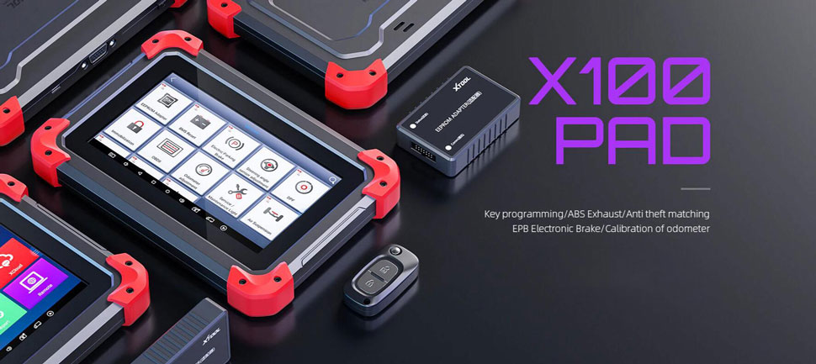  
  
Xtool X100 PAD is the first tablet key programmer in the world! It not only provides customers with professional key programming, but also the most needed special functions for workshop. X-100 PAD is a tablet with the latest technologies to perform key programming, mileage adjustment, oil service light reset, timing belt service light reset, tire pressure warning light reset, EPB reset, throttle body reset, DPF reset, battery reset, steering angle calibration and OBD-II engine diagnosis.

**XTOOL X100 PAD Highlights:**  
  
**1. Multi-Language:**English, German, French, Spanish, Italian, Japanese, Portuguese, Russian, Korean, Finnish, Arabic and Polish  
**2. Functions:**Not only immobilizer, also support odomter adjustment and specical service functions  
**3. Wide Vehicle Coverage  
4. Personalized Operation Interface:**Brand-new interaction design interfaces and detailed operation reminder. Make operation easy and more obvious.  
**5. Hign-end Appearance:** Simple and hign-end appearance ,It is more duable with a protecive case  
**6. One-Click Updat Online:**Free Update for Two Years. After two years, it will be 200usd per year.  
Check [**XTOOL X100 PAD Update Service**](https://www.uobdii.com/wholesale/one-year-update-service-for-xtool-x100-pad.html) **Dealer Code: XT0240**

**XTool X100 PAD Functions:**

Key programming

Oil Reset/Engine oil light reset

Odometer Adjustment

Tire Pressure Warning Light Reset (Manual Operation)

Timing belt light reset (Manual Operation)

EPB Electrical Parking Brake Adaptation

TPS Throttle Body Adaptation

Steering Angle Calibration

Battery Reset

PIN Code Reading

Hexadcimaleditor(Win Hex)

OBDII Diagnosis

Support the latest vehicles with CAN BUS and UDS protocol

Update Via WIFI (always equip your device with the latest software)

More…

**XTOOL X100 PAD Key Programming Features:**

1.New keysprogramming

2.PIN Code reading with EEPROM

3.Hexadcimal editor(Win Hex)

4.Reads keys from immobilizer's memory

5.New immobilizerprogramming

6.Vehicle Identification Number programming

7.Reset ECM & reset immobilizer

8.New remote controller programming

9.With full and strong database for the most important vehicle makes   
  
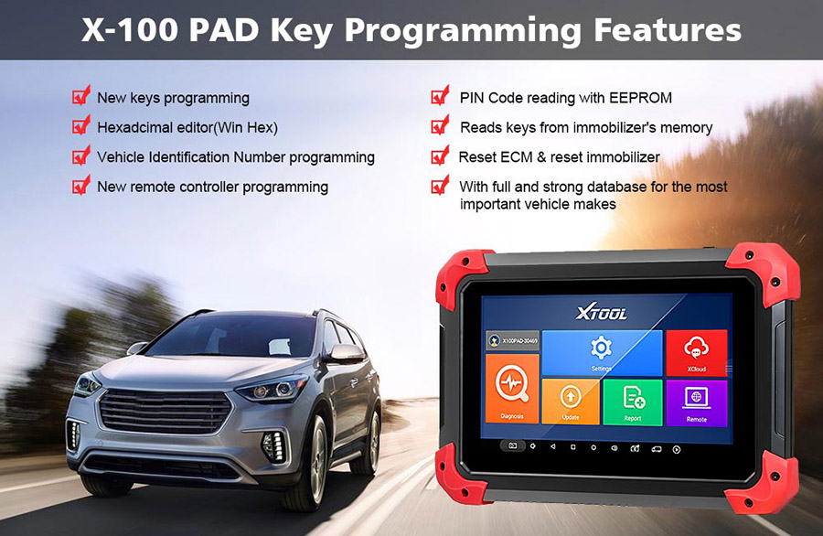

**XTOOL X100 PAD Key Programming Vehicle Coverage:**

**Asia:**Toyota, Lexus, for Honda, A cura, Mazda, for N issan, Infiniti, Mitsubishi, Subaru, Suzuki, Kia, Hyundai, Daewoo, SSANGYONG, Proton, etc

**Europe:** for Audi, VW, Skoda, Seat, for P orsche, Opel, Citroen, Peugeot, Jaguar, for L and Rover, Lincoln, Renault, etc

**America:** for G M, C adillac, B uick, Chrysler, F ord etc

**China:** Great Wall, Chery, Brilliance-auto, Geely, LIFAN, HAFEI, CHANGAN, LANDWIND, BYD, BYD , JAC, etc. 

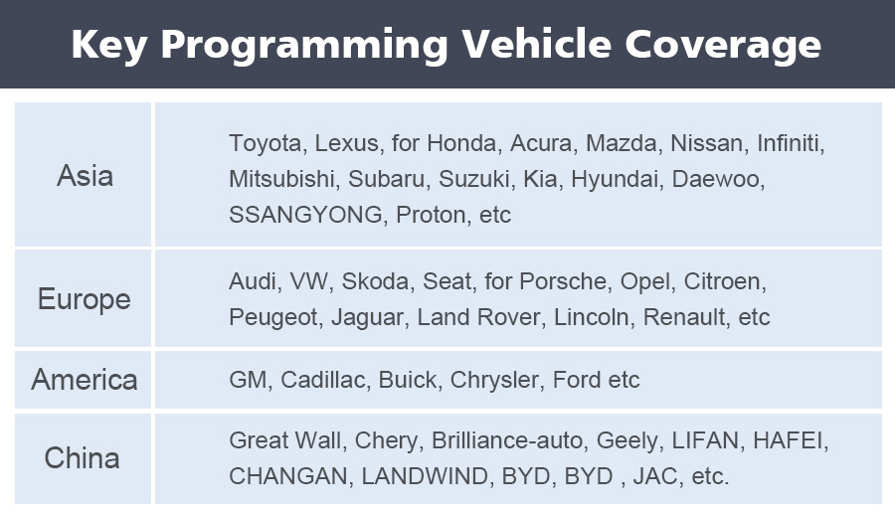

**XTOOL X100 PAD Oil Reset Functions Feature:**

Innovative one-click oil reset for vw, for audi,for  b mw, mercedes seat, skoda, volvo, etc.

Support engine oil, spark plugs, front brake pads, back brake pads, air conditioner, brake liquid, coolant liquid,  
vehicle checking , etc. resetting for bmw.  
and the supported bmw models are F01/F02/F03/F04/F07/F10/F11/F12/F13/F18/F20/F30, etc.

Support Mercedes Benz new C class, E class models and for mercedes benz VITO/VIANO/SPINTER.

Support the lifespan percentage resetting of engine oil for B uick, C adillac etc.

Support P orsche cayenne, panamera till 2012

Support maintenance light reset for volvo, l and rover.   
  
**XTOOL X100 PAD Oil Service Light Reset Vehicle Coverage:**  
   
America: B uick, C adillac, C hevrolet, Chrysler, C hevrolet/ G MC,  F ord/Mercury/Lincoln, Oldsmobile, P ontiac, Saturn, for G M, J eep and more…   
European: VW, for Audi, P orsche, for B MW, for Mercedes-Benz, Volvo, L and Rover, Peugeot, Citroen, SAAB, Seat, Skoda and more…   
Asia:Toyota/Lexus, N issan/Infiniti, for Honda, A cura, Isuzu, Chery, F ord Transit, Roewe, MG and more…   
  
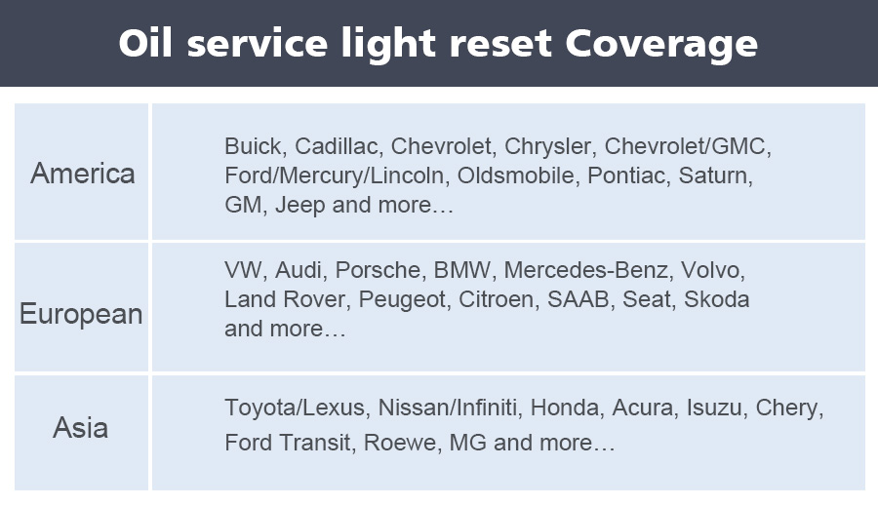

**XTOOL X100 PAD Odometer Adjustment:**

VW /for AUDI/SEAT/SKODA, B UICK, C ADILLAC, C HEVROLET, CHRYSLER, F ORD, MAZDA, NISSAN, SUZUKI, KIA, HYUNDAI, JAGUAR, L AND ROVER, P ORSCHE and more…

**XTOOL X100 PAD EPB electrical parking brake adaptation**

vw ( R36, CC, Magotan etc.), for audi ( A4L, A6L, Q5 etc.), seat, skoda and more…

Tire pressure warning light reset (manual operation)

for mercedes-benz, for g m, vw, for bmw, toyota and more…

Timing belt light reset (manual operation)

Exhaust gas treatment (DPF) features

**XTOOL X100 PAD EEPROM adapter features:**

1. PIN Code Reading

2. ECU Initializing

3. Chip Programming   
  
**XTool X100 Pad Parameter:**  
  
Display：7 Inch IPS 5-Point Multi-touch Screen with 1024×600P Resolution  
Operating System：Android 5.1.1  
Power Voltage：3.7V  
Operating Temperature：-20 to 50℃(-4 to 126℉)  
Dimension：(L*W*H): 208*140*15.5mm  
Sensors：Gravity Sensor, Light Sensor  
Humidity：<90%  
Power Consumption：4W  
CPU：Quad Core, 1.6 GHz  
Wi-Fi：WIFI 2.4Ghz  
Bluetooth：100 Meters  
Memory：1GB RAM，32GB Flash  
Battery：4000mAh, 3.7V

**XTOOL X100 PAD Package includes:**

1pc x X-100 Tablet

1pc x OBDII 16Pin Adapter

1pc x Honda-3

1pc x Kia-20

1pc x Kia/Hyundai-10

1pc x Power Adapter

1pc x EEPROM Adapter

1pc x EEPROM IC Board

1pc x EEPROM Package Box

1pc x Test Main Cable

1pc x Mirco USB Cable

1pc x User's Manual